**REPORT**

**MARKET ANALYSIS IN FRANKFURT AM MAIN - GERMANY**

**TO:** Client

**FROM:** Anderson Frigo

**DATE:** 17/03/2021

**OBJECTIVE:** Define suitable locations for a new restaurant business in Frankfurt am Main, Germany

**1) Introduction**

**1.1) Background**

Frankfurt at Main is known as a very international city in Germany. The developed bank and finance sectors continuously attract skilled workers from abroad. As a consequence, demands on other sectors such as hotels, properties, restaurants, entertainment, and transportation are also increasing and prices are skyrocketing as a consequence.

To support these changes, the city is opening credit lines for local entrepreneurs to invest in these sectors and enjoy this economical growth.

Observing a good opportunity and knowing that the German cuisine is not quite appealing for foreigners, a skilled Brazilian chef de cuisine decided to apply for the available credit line and also invest all his savings in opening a Philippine restaurant.

However, the soon to be a restaurant owner is aware of the challenges ahead and given that I) the target clients are very demanding, II) the restaurant location has to be close to the finance and banking area, and III) that the prices of renting in the city are soaring,therefore the business location is crucial for its long-term success. The client also gave the following rules and recommendations:

1. The new location has to be at a maximum of **1 km** away from the Commerzbank Tower.
2. The new location has to be at a minimum of **200 meters** away from any other restaurant and **400 meters** away to any other Asian restaurant, such as Japanese, Thai, Vietnamese or Indian.
3. If possible, close to the Main River and/or to attractions.
4. The client requires visual information on the locations to help the decision-making process.

1**.2) Problem**

The chef de cuisine hired a young data scientist to locate possible good places for the new business. As previously described, the restaurant has to be within walking distance from the center of the financing neighborhood, close to popular attractions, and avoid being close to other restaurants.

After obtaining and cleaning the obtained dataset, using Python, clustering and some GIS knowledge the data scientist has to program an algorithm to determine hotspots for the restaurant implementation.

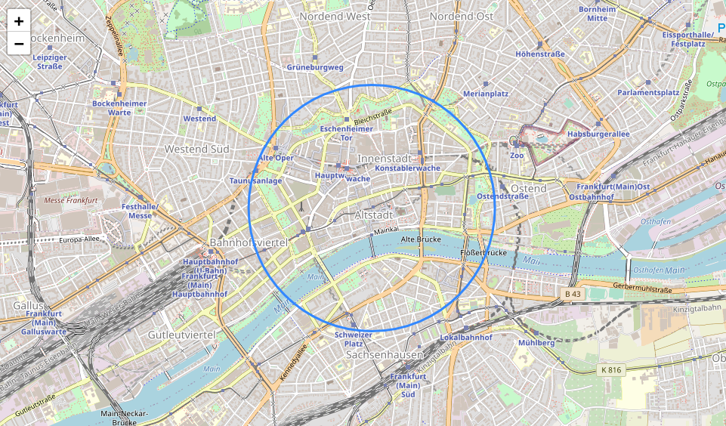Figure 1: Target area, the blue circle defines a 1 km radius from the Commerzbank Tower

**2) Data**

The area for the new business location is the Frankfurt banking neighborhood. The analysis will require Foursquare API to retrieve all available information within the region, such as rating, description, and popularity of restaurants and attractions. The API retrieves a JSON file that can be converted to a Pandas Data Frame for further analysis.

A real estate agent pre-selected 20 available points for the restaurant and sent the latitude and longitude of these locations in a CSV file.

**3) Methodology**

As previously mentioned, Python is the programing language used for this market research. Making use of specific libraries, data was imported as JSON objects and converted to tabular format (Dataframes), which facilitate data handling and analysis.

The imported dataset consists mainly of 2 tables:

1. Venues table: using the Foursquare API, a table containing all the venues within the target area was imported. As presented in Fig. 2, this table consists of the business name, category, latitude, and longitude.

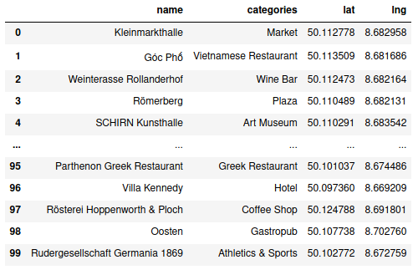

Figure 2: Venues Dataframe - screenshot with sample rows

1. Available properties for rental: a real estate agent provided a list containing 20 pre-selected locations. This dataset is originally CSV and was also imported as a Dataframe. As shown in Fig. 3, it consists of the location name, latitude, and longitude.

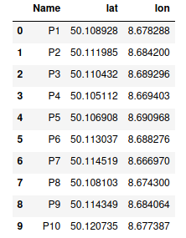

Figure 3: Available properties Dataframe - screenshot with sample rows

To confirm that the dataset is consistent, we plotted maps with all venues (Figure 4) and available properties for rental (Figure 5).

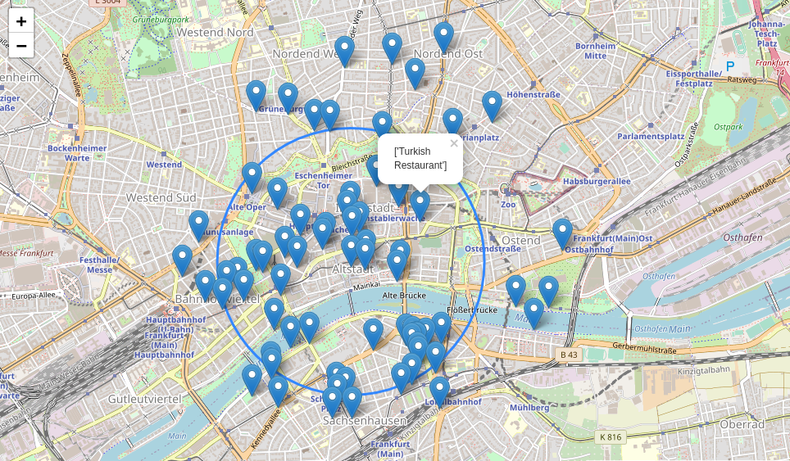 Figure 4: Interactive map with all venues marked and labeled

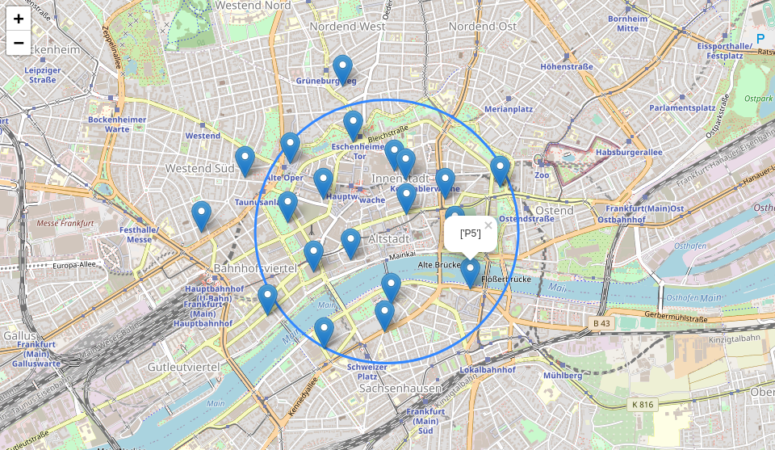Figure 5: Interactive map with all available rental locations marked and labeled

The venue table presents different categories of businesses, such as restaurants, markets, and coffee shops. To better research the region, we reorganized the venues into 4 categories: restaurants, bars, coffee shops, and attractions.

It is important to remember that the client presented some constraints regarding the new location. It has to be 200 meters away from any other restaurant and 400 meters away from Asian restaurants. Then, we classified all restaurant venues into "Asian" or "non-Asian restaurant".

To present the results more clearly, we used histograms and generated interactive maps. The histograms count the frequency of venues and restaurant categories. The maps create buffer zones around attractions (green circles), Asian restaurants (red circles, a radius of 400 m), and non-Asian restaurants (blue circles, a radius of 200 m). Finally, all maps are saved as HTML files and can be handled interactively.

Finally, a list of the suitable rental locations will be assessed using a dedicated geospatial library of Python (geopy). These locations follow the guidelines presented by the client.

**4) Results**

The client requested that we should not only identify list the rental locations but also provide some insightful visual information to help him in the decision-making process. This was done by presenting information about the venues and creating maps.

Figures 6 and 7 present histograms of the venues and restaurant categories respectively. Although the majority of the venues in the region are indeed restaurants, fortunately, we can observe that most are not Asian, which presents fewer constraints in the identification of the rental location.

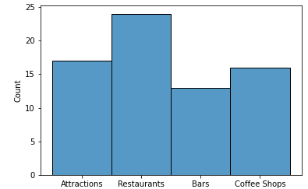

Figure 6: Histogram with venues categories in the target area

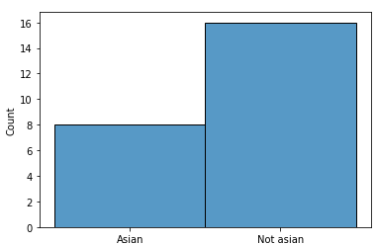

Figure 7: Histogram with restaurants categories in the target area

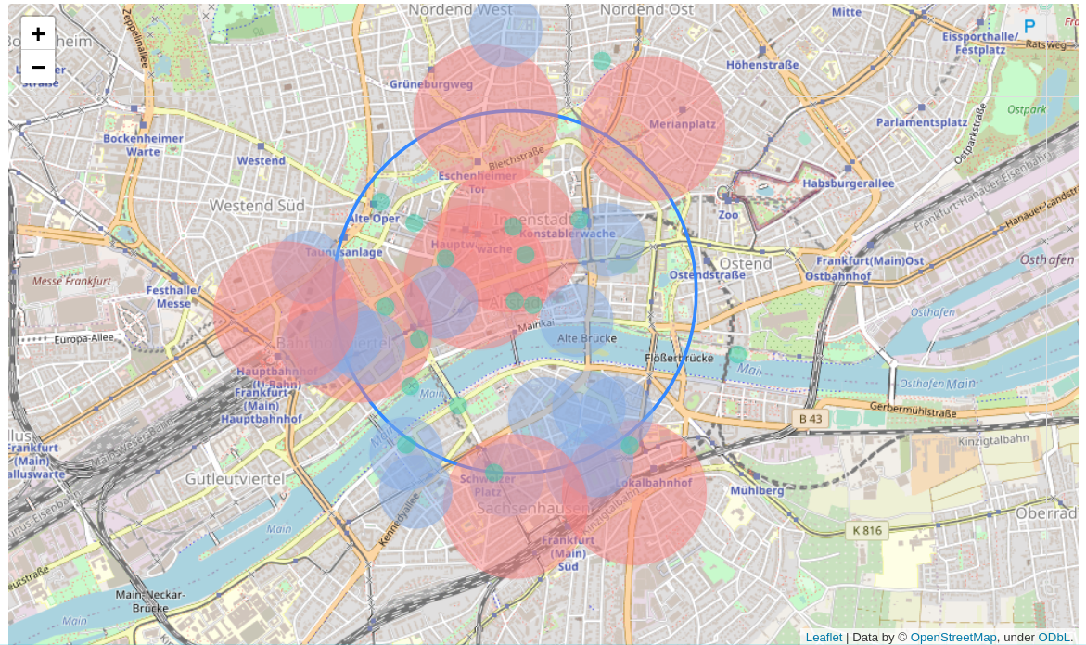Figure 8: Interactive map presenting buffer areas of Asian restaurants (red circles), non-Asian restaurants (blue circles) and attractions (green circles)

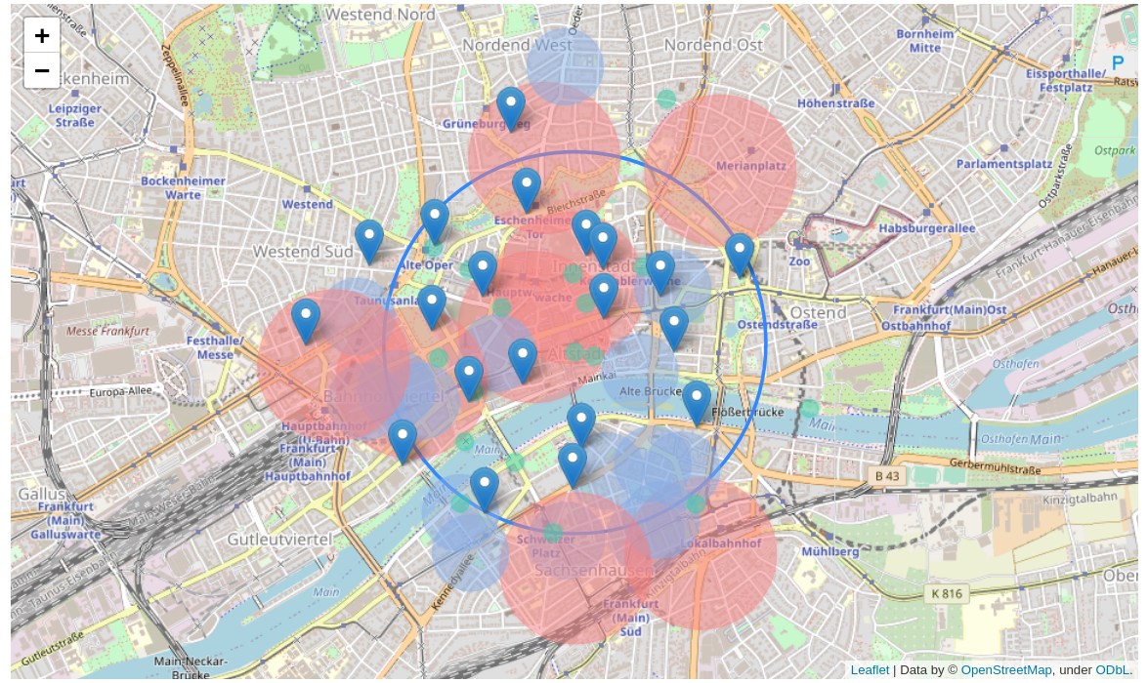Figure 9: Interactive map presenting buffer areas of Asian restaurants (red circles), non-Asian restaurants (blue circles), attractions (green circles) and all available rental locations

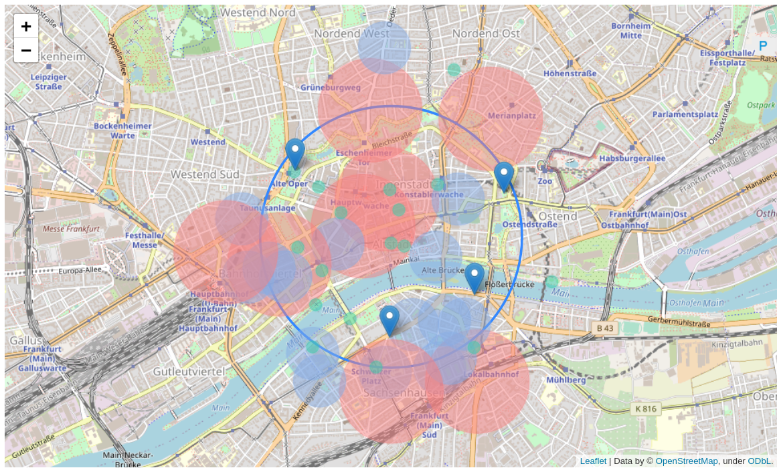Figure 10: Interactive map presenting buffer areas of Asian restaurants (red circles), non-Asian restaurants (blue circles), attractions (green circles) and all suitable rental locations

P11

P16

P20

P5

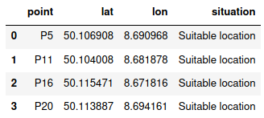

Figure 11: Suitable properties for rental

**5) Discussion**

Figures 10 and 11 summarize all relevant results obtained in this research. Locations P5, P11, P16, and P20 are all suitable and respect the pre-defined constraints. We also recommend that the client inspects the generated interactive map for further analysis. In the following we detail briefly each suitable location:

* P16: this point is located in the north-west direction of the neighborhood. Among the suitable points, this location has the greatest distance from any other restaurant and is very close to a famous attraction in Frankfurt, the Old Opera House. However, is far from the river and is almost within the limit of walking distance set by the client.
* P20: this point is located in the north-east direction of the neighborhood. Similar to P16, is almost within the limit of walking distance. As its main advantages, this point is located within a public park, is close to the city zoo, and a major train station (Frankfurt Ostbahanhof).
* P11: this point is located in the south direction of the neighborhood, in the south margin of the Main river. Its main advantages are the proximity to the river and popular museums. However, among the other points, this location is the closest to other restaurants, where 2 are Asian.
* P5: this point is located in the south-east direction of the neighborhood, also in the south margin of the Main river. This location is the closest to the river and also has popular attractions nearby (Mainufer / Ostend). Another relevant aspect, this point is also close the ECB (European Central Bank), although outside the banking neighborhood, can also be a potential source of clients.

**6) Conclusion**

This report presented successfully suitable locations for a new restaurant business in Frankfurt. Following the client's guidelines, the algorithm was able to select 4 of the 20 locations provided by the real estate agent. This will not only save the client's time in personal visits but also provides him insightful information to support the decision-making process. The provided information, supported by the rental prices, will help the client in defining the best location for the new restaurant.